Certificates
Sl. No | Name of Certification Course | Name of Company / Certificate Provider | Total Course Hours | Certificate
1 | Python for Machine Learning | GreatLearning | 5 Hours | ✔️
2 | Introduction to Cyber Security | GreatLearning | 5.5 Hours | ✔️
3 | Introduction to R | GreatLearning | 3 Hours | ✔️
4 | Data Visualization Using Python | GreatLearning | 2 Hours | ✔️
5 | Financial Risk Analytics | GreatLearning | 1.5 Hours | ✔️
6 | RPA and its Applications | Alva's Institute of Engineering and Technology | - | ✔️
7 | Step into Robotic Process Automation | GUVI | 1 Hour | ✔️
8 | Data and Computer Communication Network | R. L Jalappa Institute of Technology | - | ✔️
9 | Game Development using PyGame | GUVI | 1 Hour | ✔️
10 | Technical Quiz | Netaji Institute of Engineering and Technology | - | ✔️
11 | How to develop a Pythonic coding rather than Python coding – Logic Perspective (Workshop) | Alva's Institute of Engineering and Technology | 4 days | ✔️

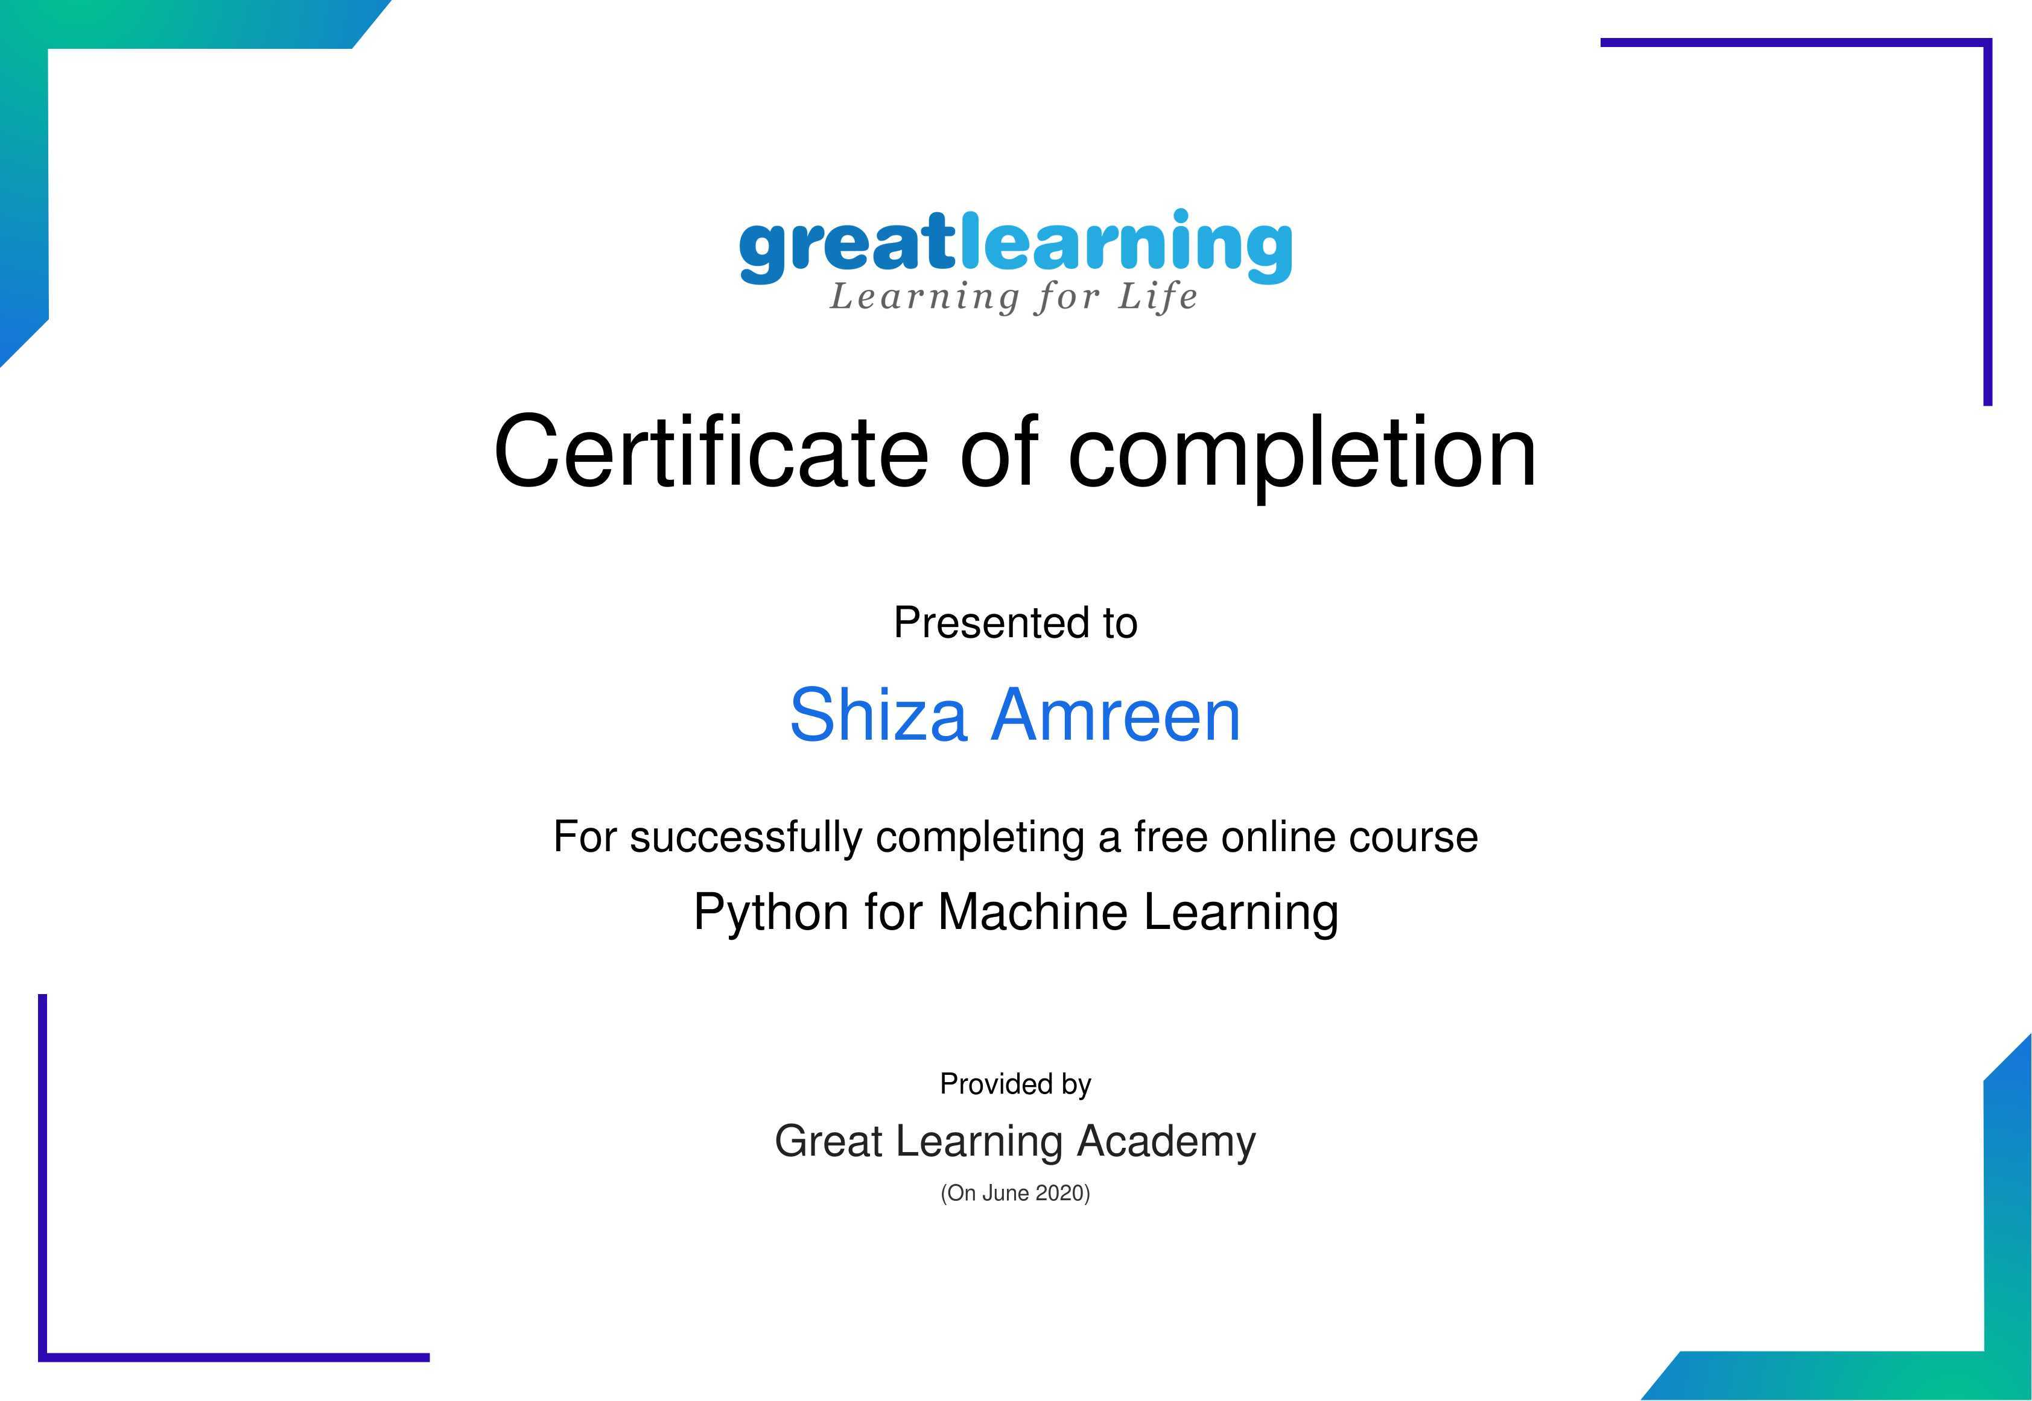
Certificates:
1.

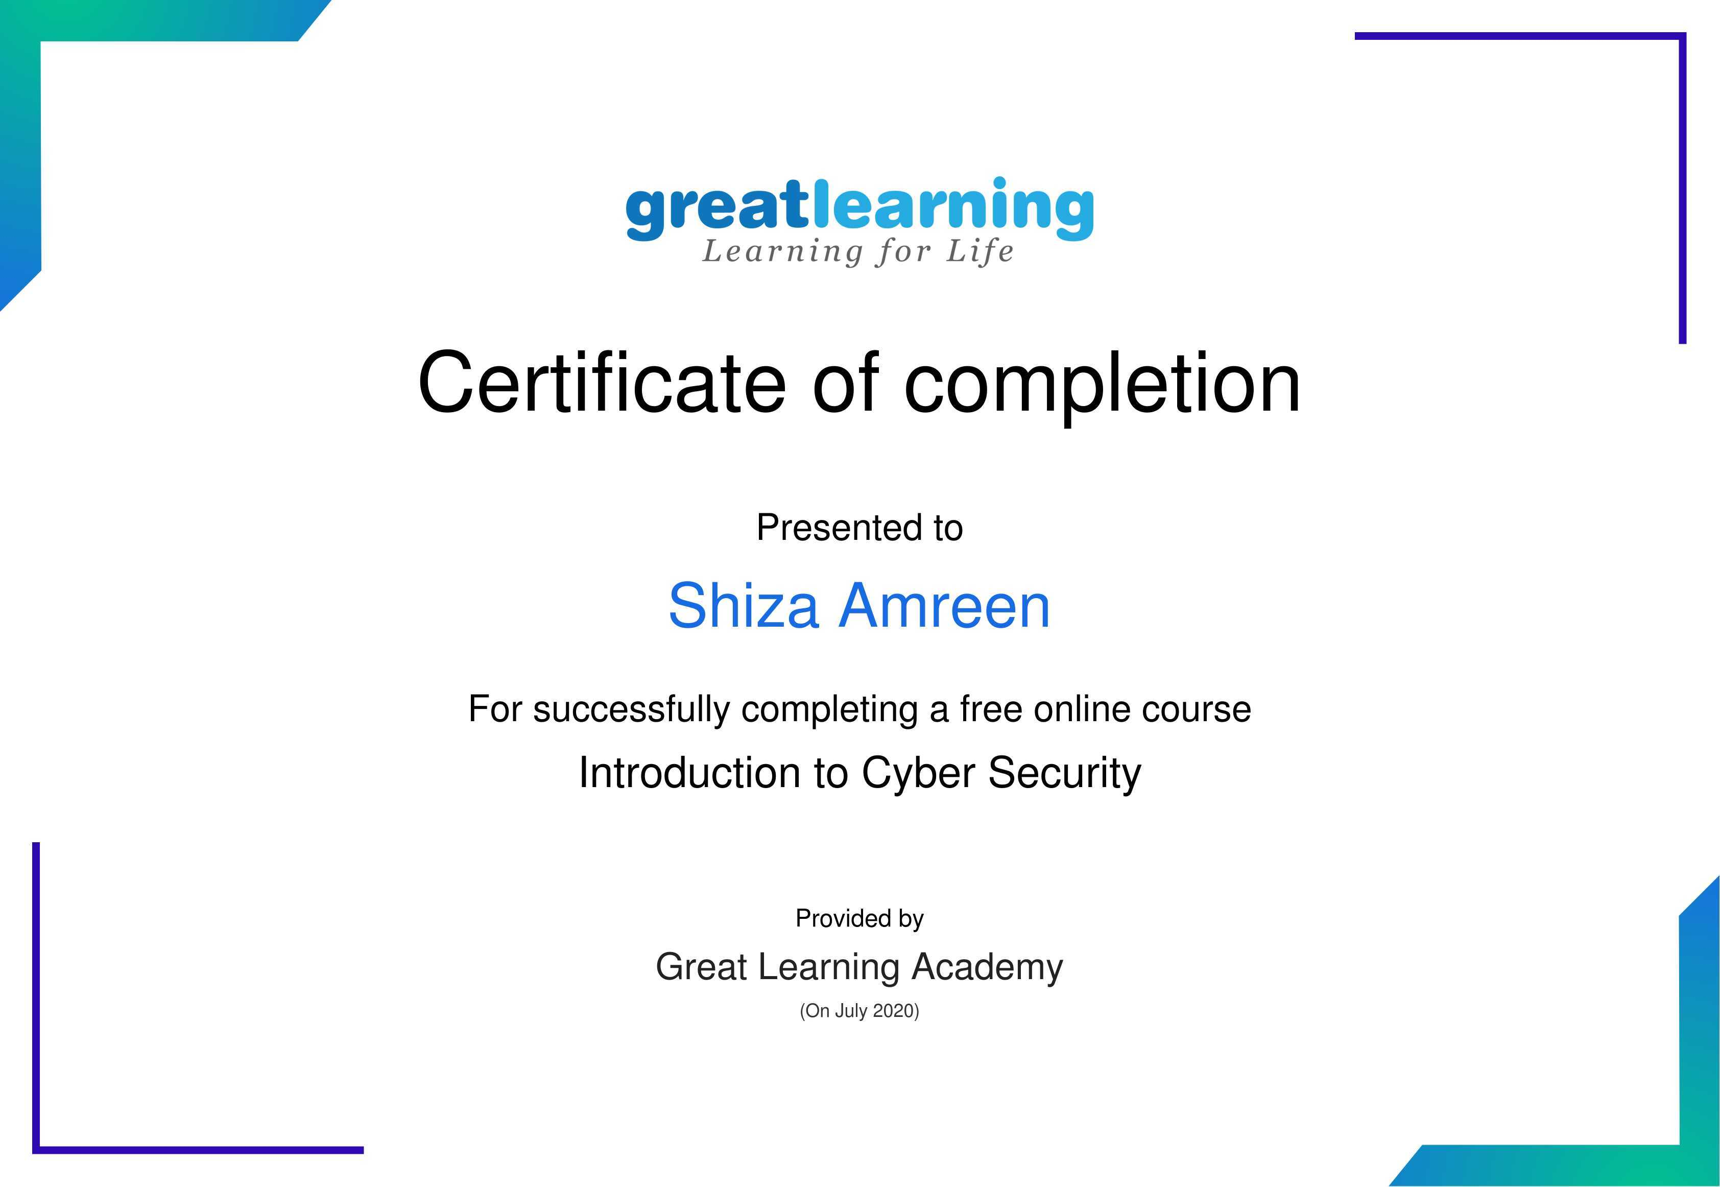
2.

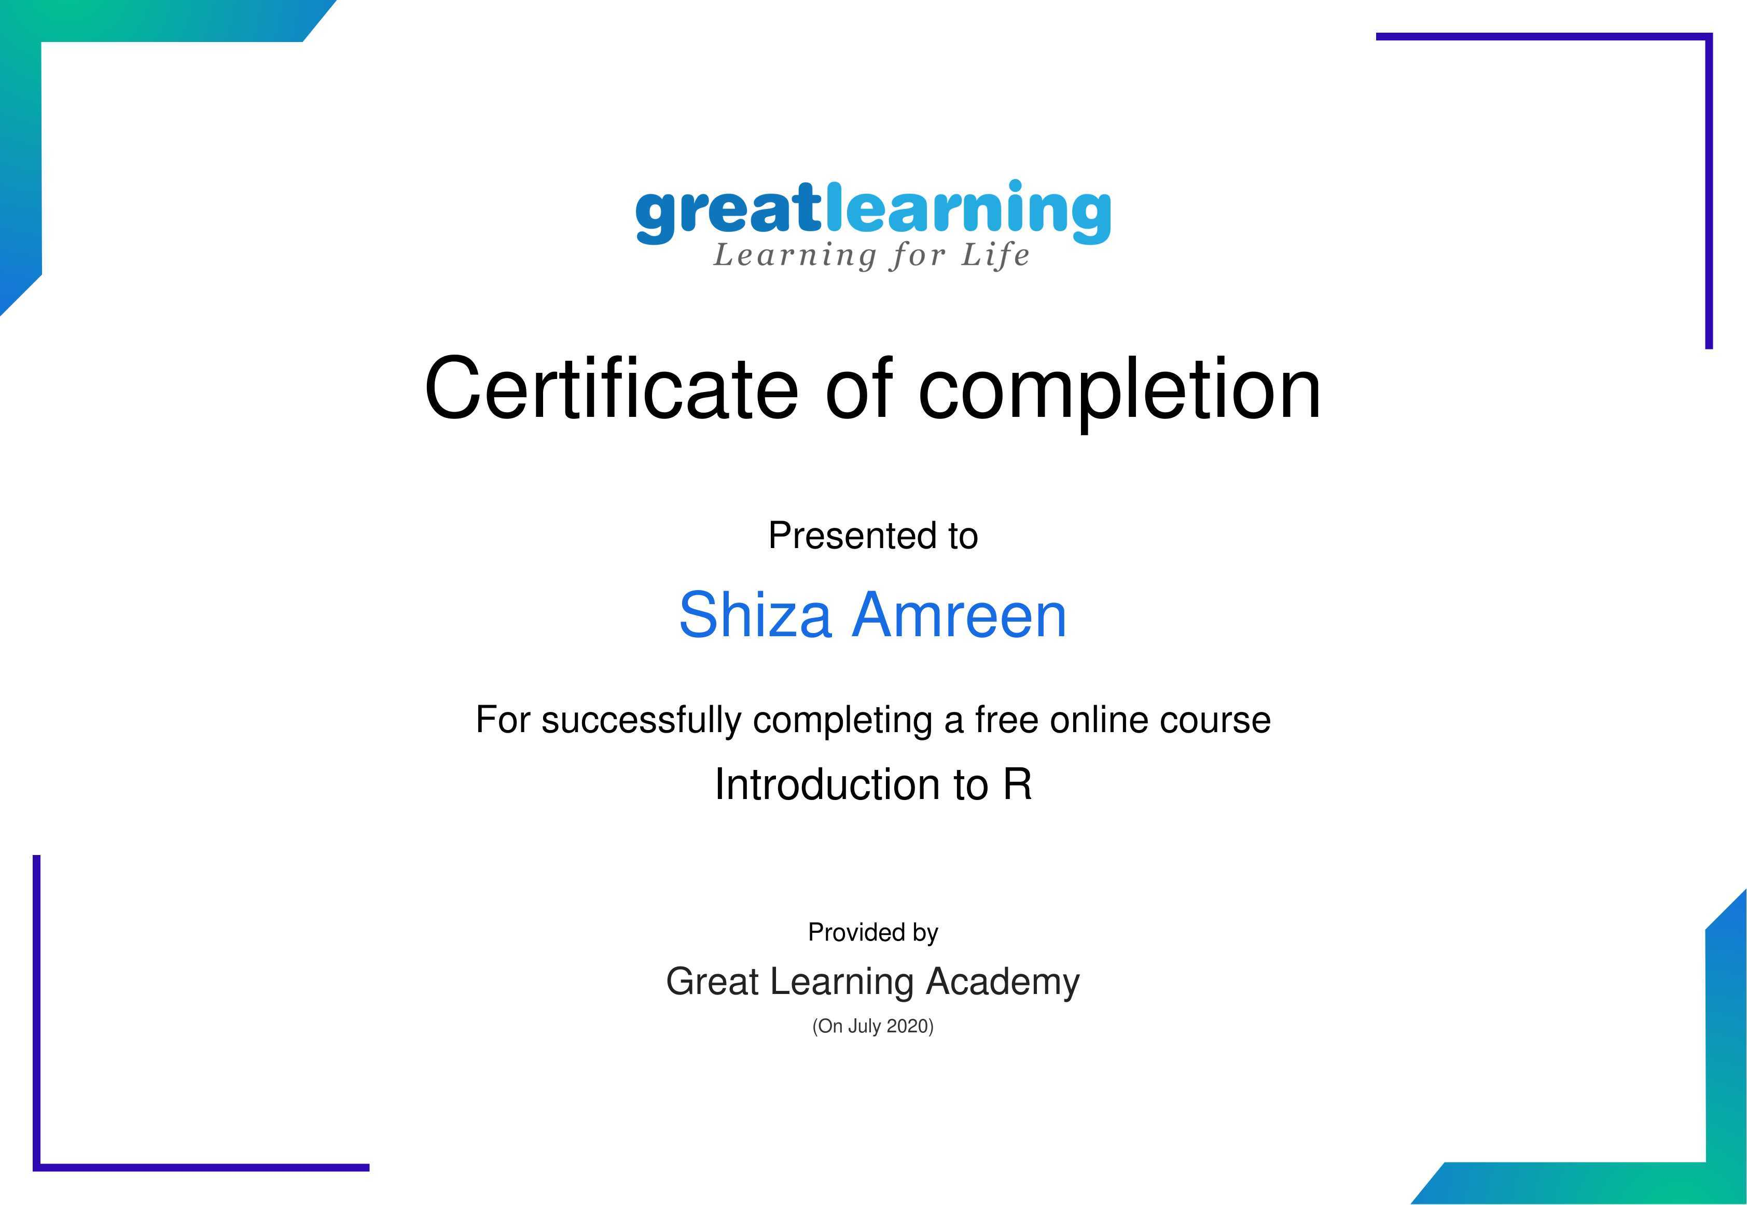
3.

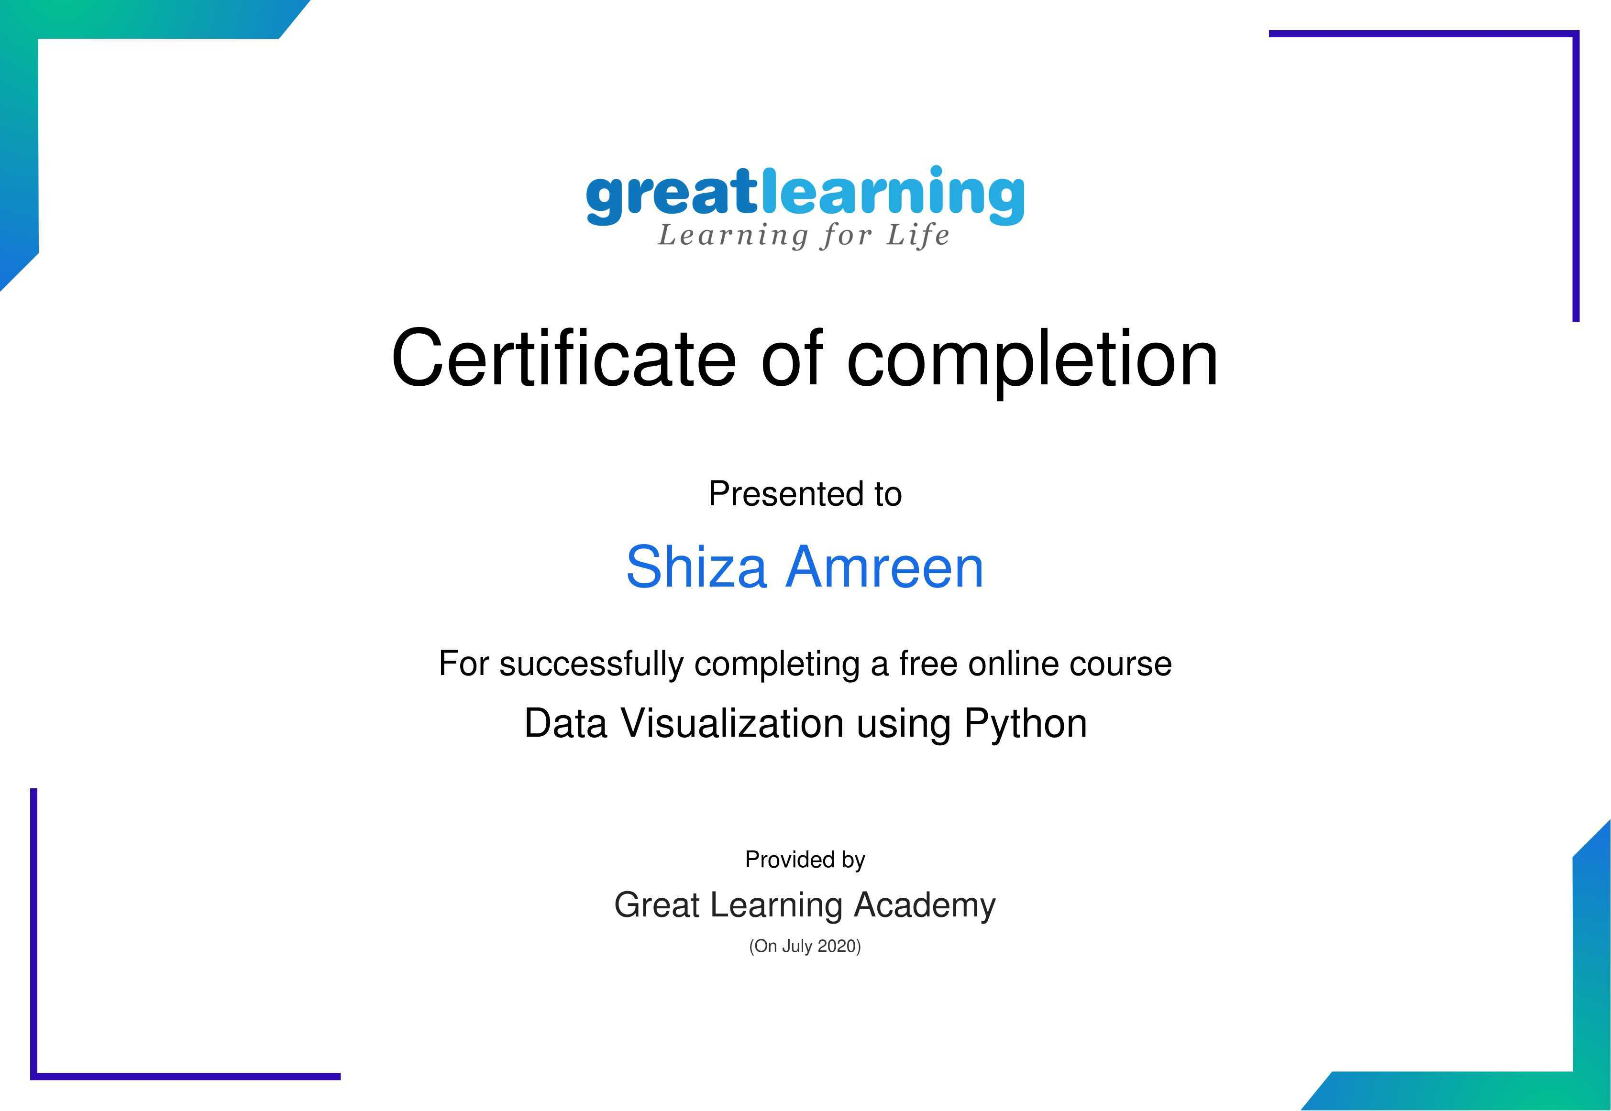
4.

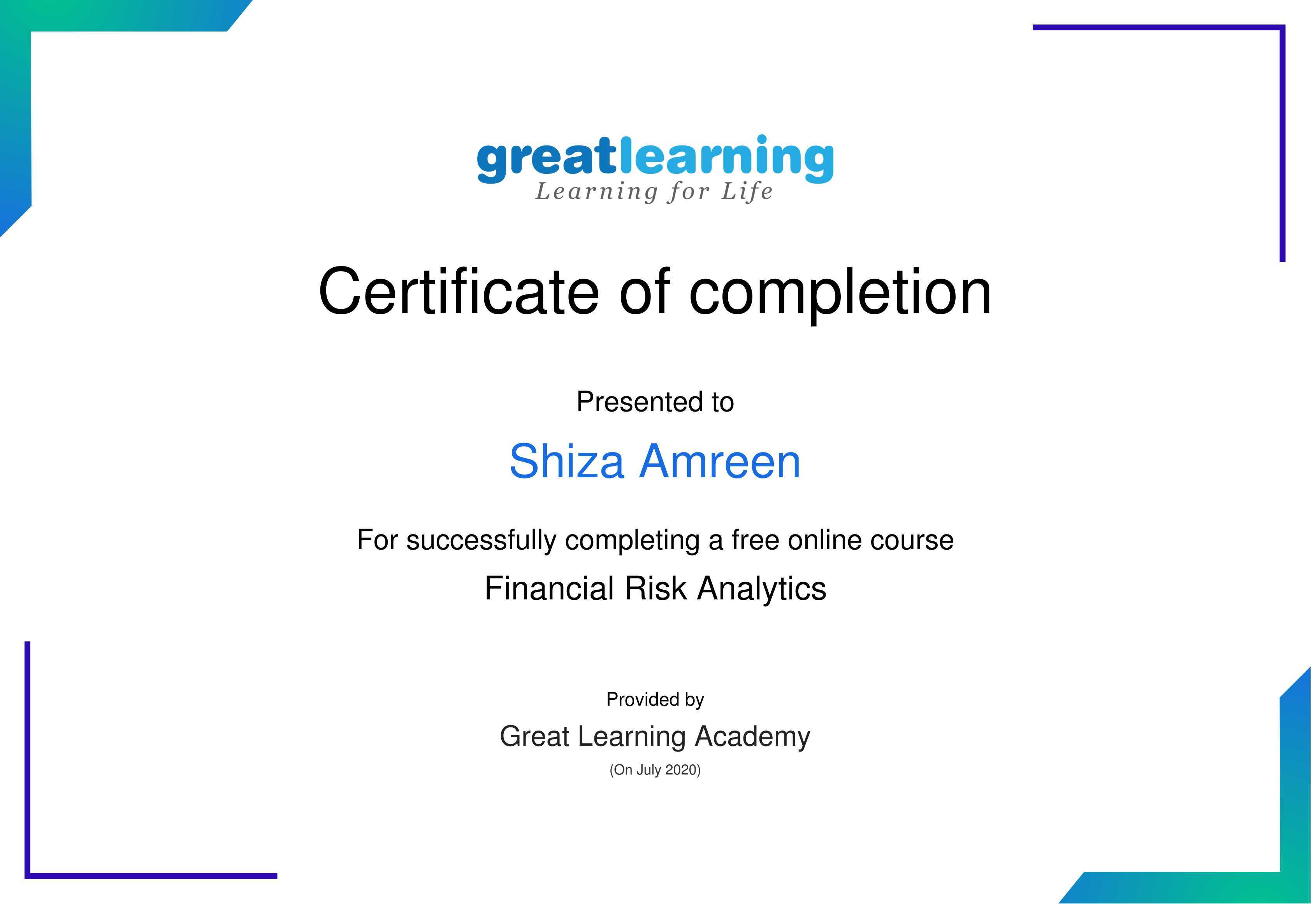
5.

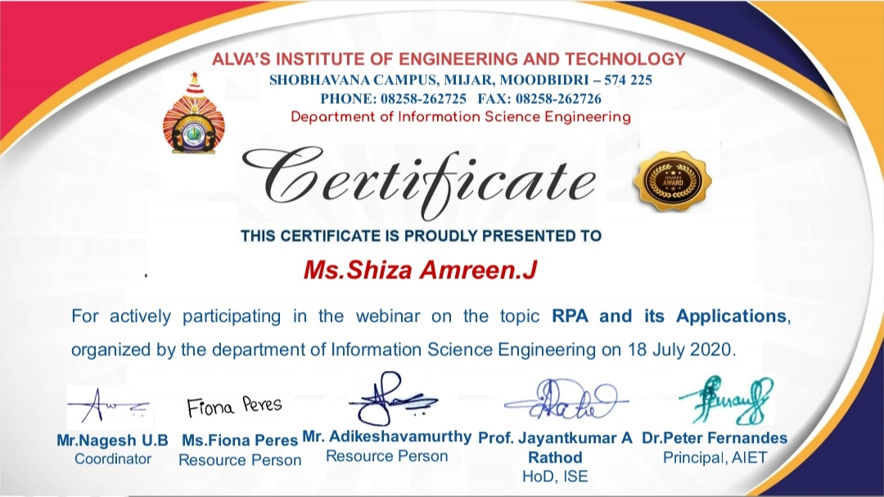
6.

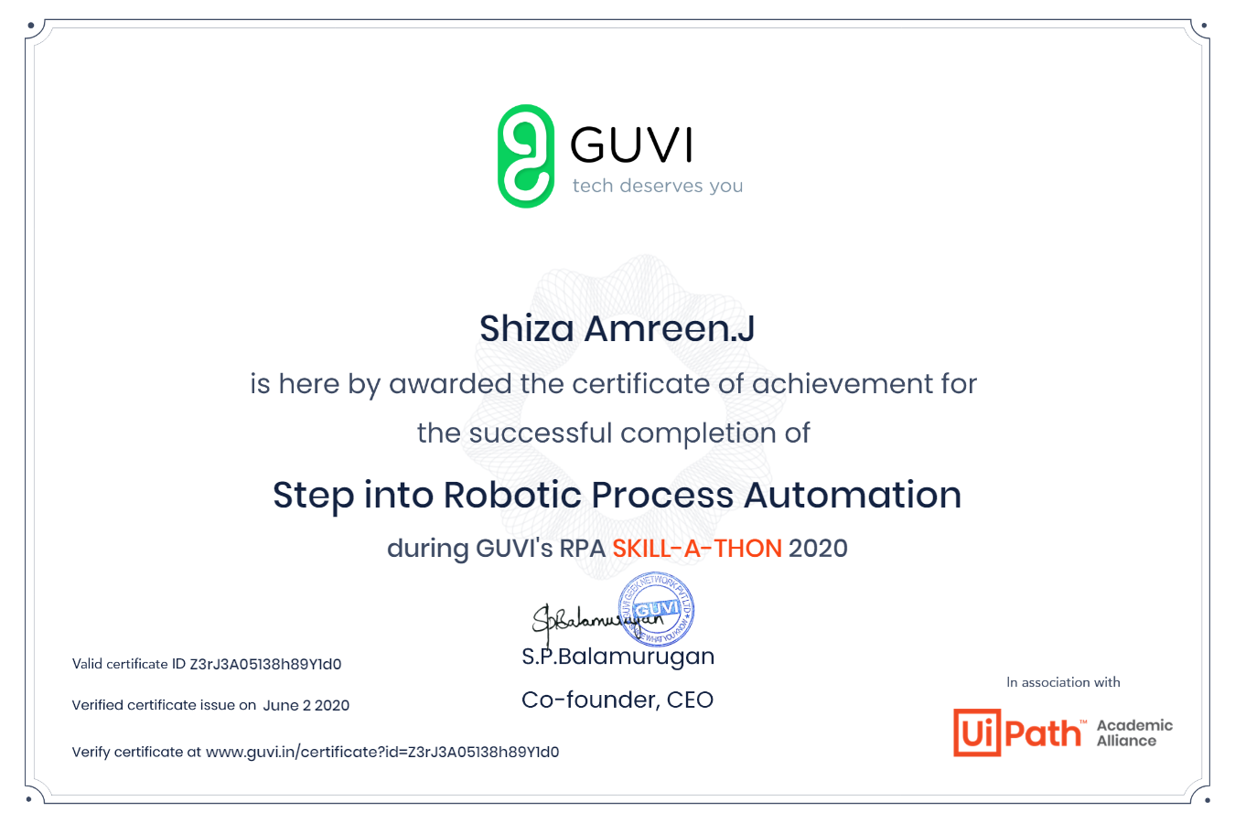
7.

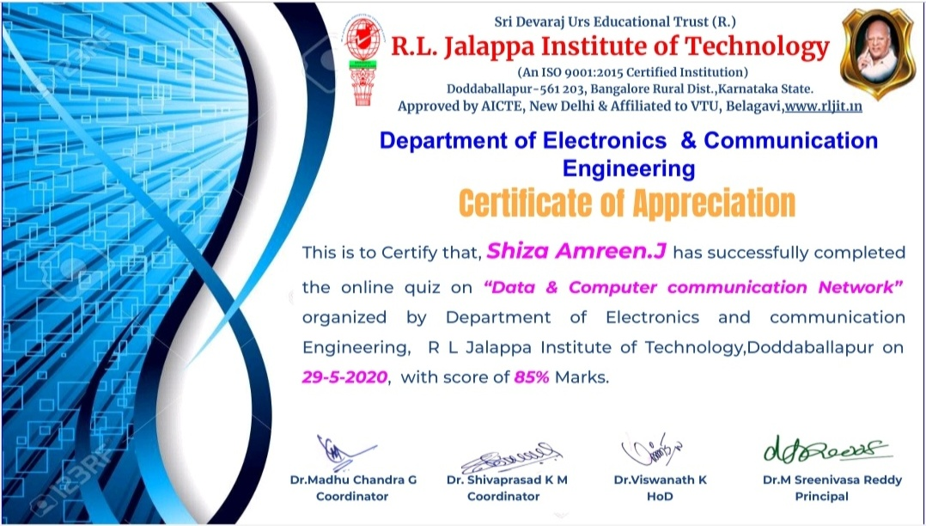
8.

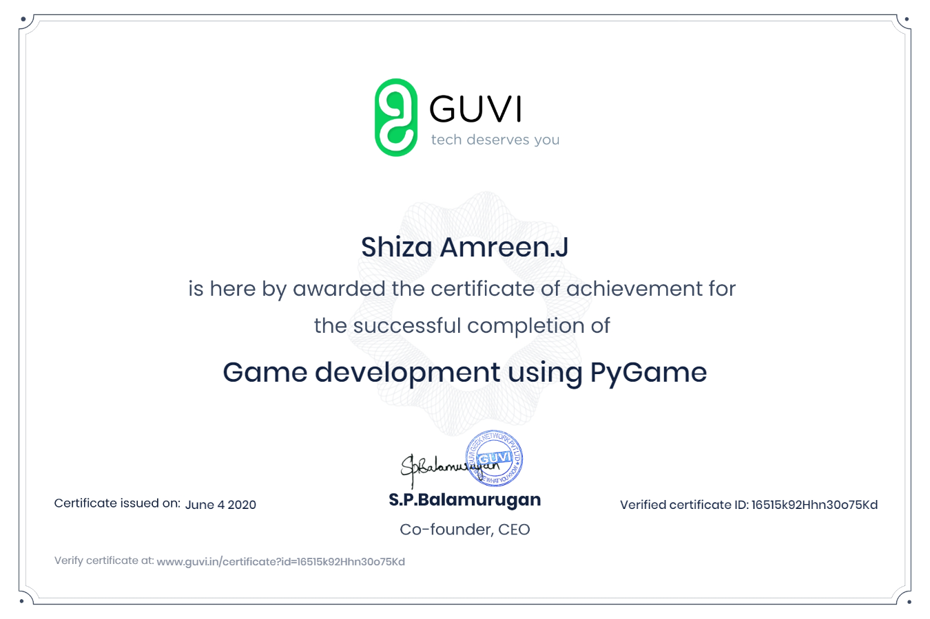
9.

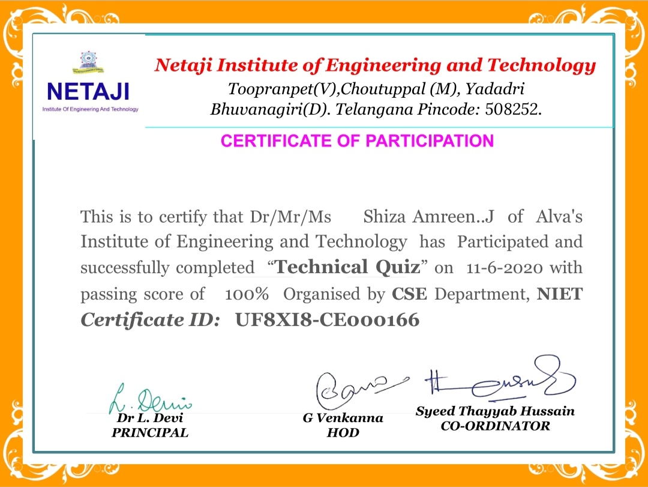
10.

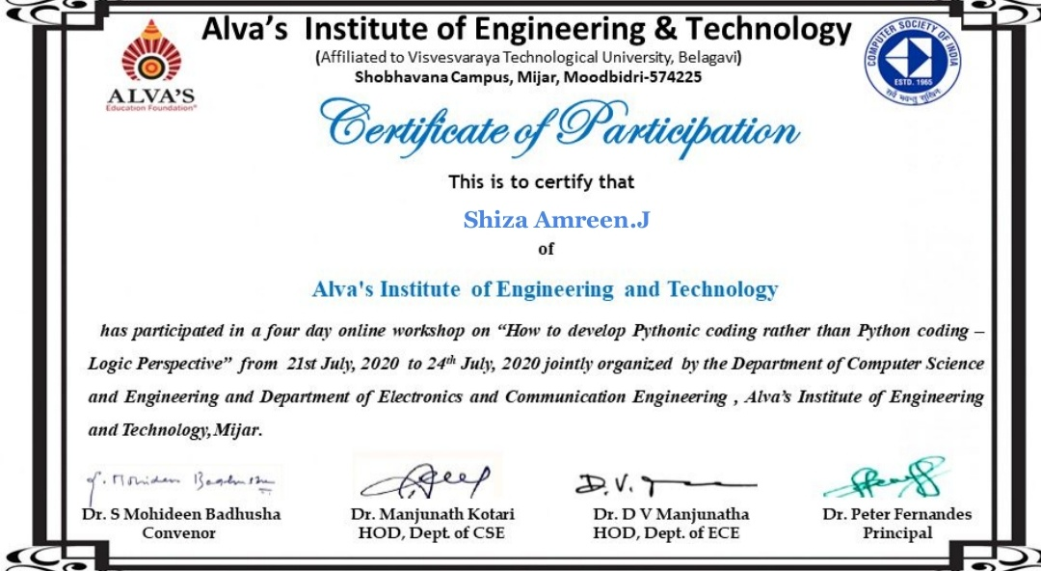
11.

